UNIVERSITY OF ENGINEERING & TECHNOLOGY
Department of Computer Engineering
SUBMITTED BY | MIAN MUHAMMAD MOEEN
ROLL NO | 2025(CYS-111-B)
SECTION | B
SEMESTER | 4TH
SUBMITTED TO | HAFIZ MUHAMMAD MUBASHAR IMRAN
LAB | 6
SESSION | 2025-2029
SUBJECT | ARTIFICIAL INTELLIGENCE LAB

LAB 6 PRATICE TASK 2

Naive Bayes Assignment Report

Spam Email Classification

Objective
To classify a new email as Spam or Not Spam using the Naive Bayes classification algorithm based on whether it contains the word “Prize.”

Given Dataset
Email | Prize | Class
E1 | Yes | Spam
E2 | Yes | Spam
E3 | No | Spam
E4 | Yes | Spam
E5 | No | Spam
E6 | Yes | Not Spam
E7 | No | Not Spam
E8 | No | Not Spam
E9 | No | Not Spam
E10 | Yes | Not Spam
New email: Prize = Yes

Task 1: Count Spam and Not Spam Emails
Total number of emails = 10
Spam emails: E1, E2, E3, E4, E5
Number of Spam emails = 5
Not Spam emails: E6, E7, E8, E9, E10
Number of Not Spam emails = 5

Task 2: Calculate Prior Probabilities
Prior probability is the probability of a class before considering the email's features.
Formula:
P(Class) = Number of emails in the class / Total number of emails
For Spam:
P(Spam) = 5 / 10 = 0.5
For Not Spam:
P(Not Spam) = 5 / 10 = 0.5
Results:
- P(Spam) = 0.5 or 50%
- P(Not Spam) = 0.5 or 50%

Task 3: Calculate P(Prize = Yes | Spam)
Among the 5 Spam emails, 3 contain the word Prize.
Spam emails containing Prize = E1, E2, E4
Formula:
P(Prize = Yes | Spam) = Spam emails containing Prize / Total Spam emails
P(Prize = Yes | Spam) = 3 / 5 = 0.6
Result: P(Prize = Yes | Spam) = 0.6 or 60%

Task 4: Calculate P(Prize = Yes | Not Spam)
Among the 5 Not Spam emails, 2 contain the word Prize.
Not Spam emails containing Prize = E6, E10
Formula:
P(Prize = Yes | Not Spam) = Not Spam emails containing Prize / Total Not Spam emails
P(Prize = Yes | Not Spam) = 2 / 5 = 0.4
Result: P(Prize = Yes | Not Spam) = 0.4 or 40%

Task 5: Calculate the Spam Score
The Spam score is calculated by multiplying the prior probability by the conditional probability.
Formula:
Spam Score = P(Spam) × P(Prize = Yes | Spam)
Substituting the values:
Spam Score = 0.5 × 0.6
Spam Score = 0.30
Result: Spam Score = 0.30

Task 6: Calculate the Not Spam Score
Formula:
Not Spam Score = P(Not Spam) × P(Prize = Yes | Not Spam)
Substituting the values:
Not Spam Score = 0.5 × 0.4
Not Spam Score = 0.20
Result: Not Spam Score = 0.20

Task 7: Compare Scores and Predict the Class
Class | Prior Probability | Conditional Probability | Score
Spam | 0.50 | 0.60 | 0.30
Not Spam | 0.50 | 0.40 | 0.20
Comparison:
Spam Score = 0.30
Not Spam Score = 0.20
Since 0.30 > 0.20, the Spam score is higher than the Not Spam score.
Predicted Class: Spam

Normalized Posterior Probabilities
To calculate the final probabilities, divide each score by the sum of both scores.
Total Score = 0.30 + 0.20 = 0.50
For Spam:
P(Spam | Prize = Yes) = 0.30 / 0.50 = 0.60 = 60%
For Not Spam:
P(Not Spam | Prize = Yes) = 0.20 / 0.50 = 0.40 = 40%

Conclusion
The Naive Bayes algorithm classifies the new email as Spam because its Spam score (0.30) is greater than its Not Spam score (0.20). The normalized posterior probabilities are 60% for Spam and 40% for Not Spam.
This assignment demonstrates how prior probabilities and conditional probabilities can be used to classify an email into one of two categories.
CODE:-
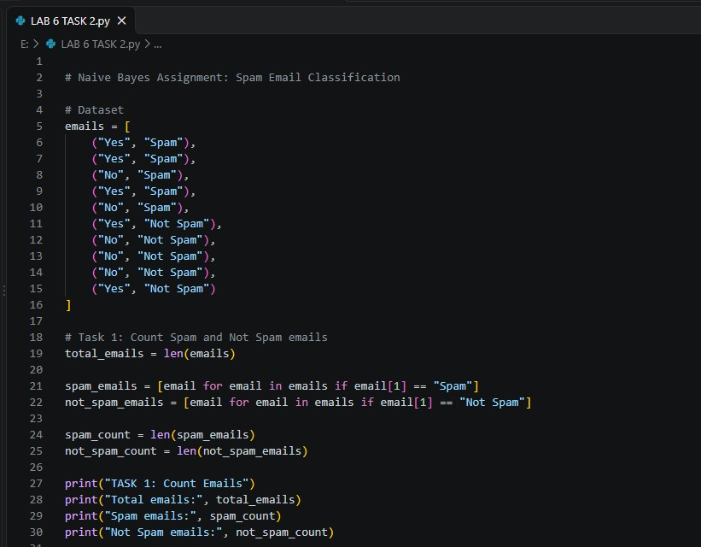
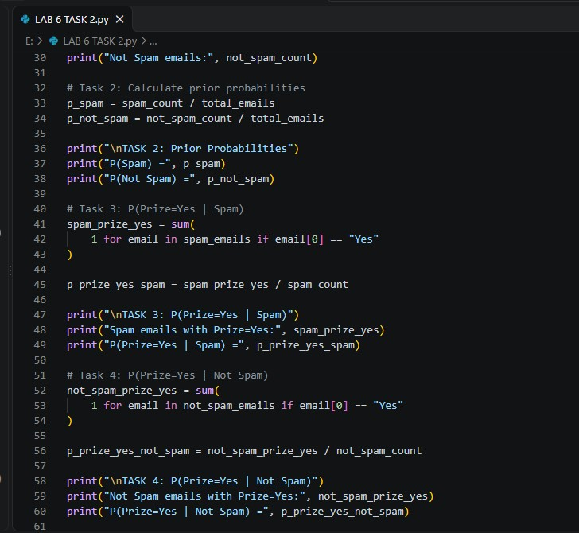
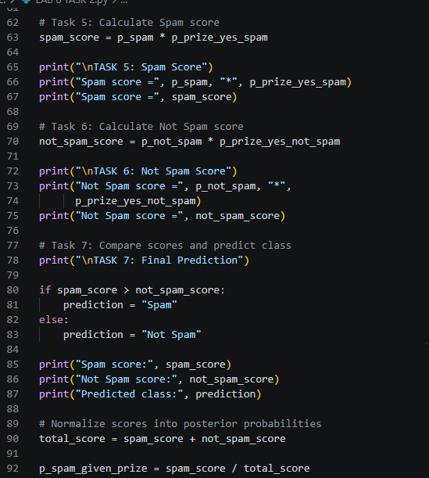
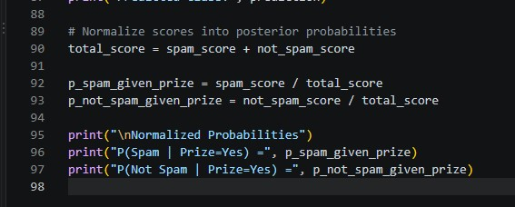
OUTPUT:-


